 | Concur  Reference Guide  Request  03/22
Table of Contents
Travel Request 2
Creating a Travel Request 2
International Travel Request 8
Blanket Travel Request for Mileage 8
Liability Only/Unfunded Travel Request 9
Acting as a Delegate/ Travel Arranger 10
Requesting a Cash Advance 11
Altering a Request 12
Replacing a Request 12
Cancel a Request 13
Closing/Inactivating a Request 14

Travel Request

Creating a Travel Request

To create a request:
- Either:
Click Requests on the header toolbar, and then select the Create New Request tile on the request page.

Or:

From the dashboard page, click + New and select Start a Request.

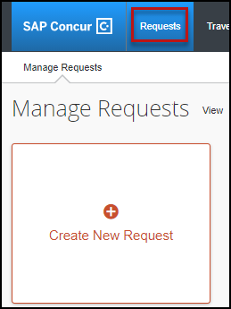 | OR | 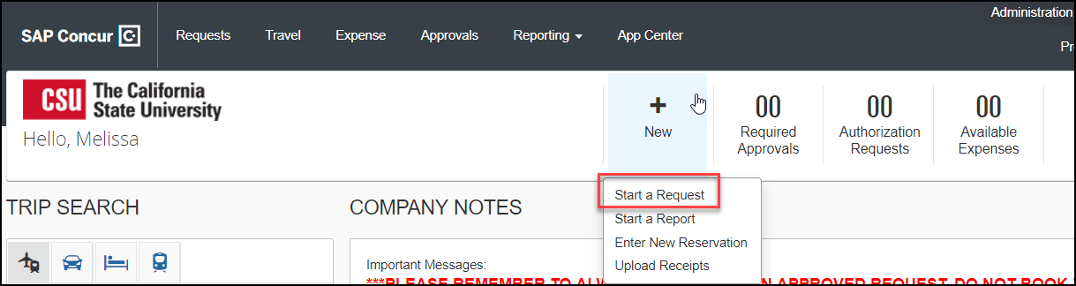

- The Request Header tab appears. Complete all required fields with a red asterisk.
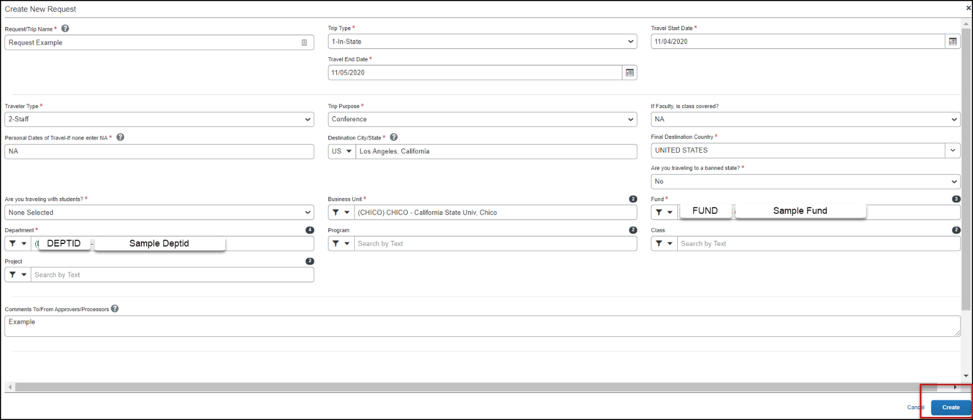

See field descriptions and further information in the table below:
Field Name | Description
Request Policy | *CSU-Request Policy (default) should be used for all employee travel expenses. *CSU-Non-Employee Request Policy is used for reimbursing non-employee travel expenses. Please refer to Concur Reference Guide- Non-Employees (currently not in use by Sonoma).
Request/Trip  Name | Enter a meaningful trip name to help identify the trip. Your department may implement a standard naming protocol. Suggested naming convention: Conference/meeting Name, Destination City, State, and dates of Travel (ex. AAP2 Long Beach, CA 5/18-5/21). There is a 32-character limit.
Trip Type | Select from the drop-down list
Travel Start Date | Date business expenses start. If personal days precede business dates, please be sure to still set travel start date to the date you leave for the trip.
Travel End Date | Date business expenses end. If personal days are after business dates please be sure to still set travel end date to the date you return from the trip.
Traveler Type | Select from the drop-down list
Trip Purpose | Select from the drop-down list
If Faculty, is class covered? | Only Required for Faculty. Select from the drop-down list.
Personal Date of Travel | Enter all dates which are personal. If none, place NA in field.
Destination City/State | If you anticipate traveling to more than one city and/or country, enter where you plan to spend the majority of your travel time. The Comments section can be used to enter in additional destinations.
Final Destination Country | The country will pre-populate based on the destination city selected.
Are you traveling to a banned state? | Select from the drop-down list
Are you traveling with students? | Select from the drop-down list
Chartfield | Chartfield String will pre-populate based on your dept. If necessary, changes can be made by traveler or approver.

- Select Create in the lower right-hand corner of the screen.
- Add Expected Expenses, from the drop-down list or using the search function. Enter meaningful estimates for the related travel expenses. The travel request should reflect the anticipated cost for the trip and communicate the amount of campus department funding a traveler is seeking for a particular trip. The Estimated Total summarizes expected expenses and the amount that is being sought for approval. Note: if you have a limited budget for travel please make sure your travel request reflects that situation.
Sample travel request with notes about common expense choices and other navigation items.
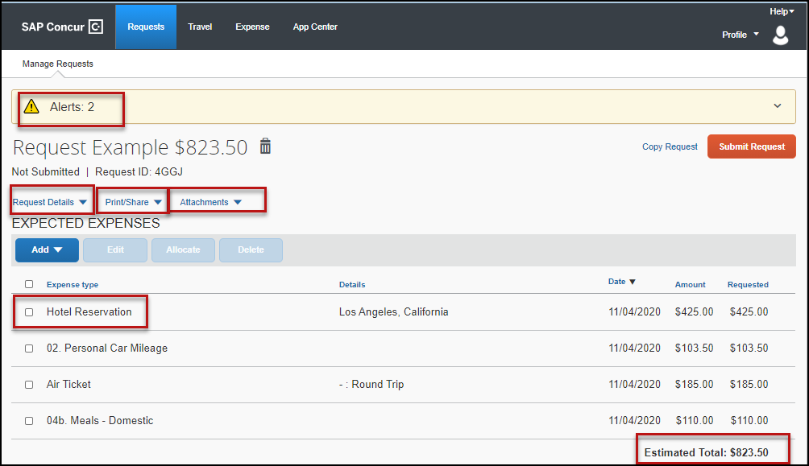
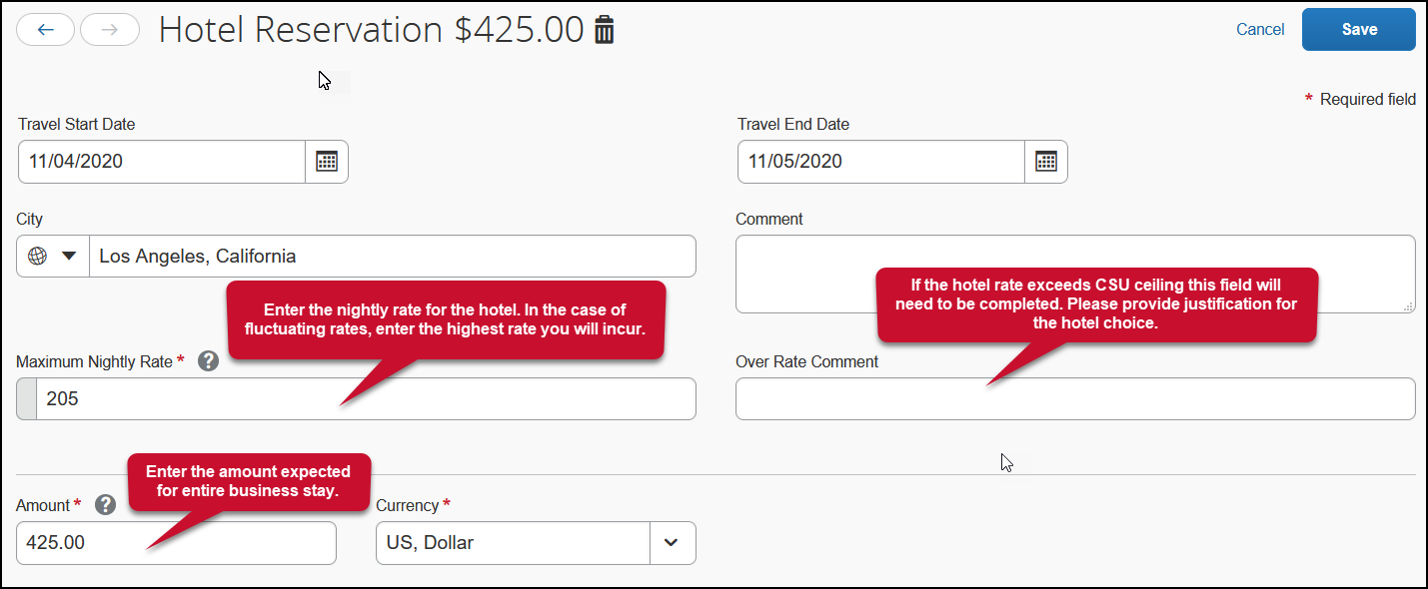
- Hotel

- Meals
Meals in request defaults to the maximum daily rate. When expensing, traveler enters actuals for daily meals.
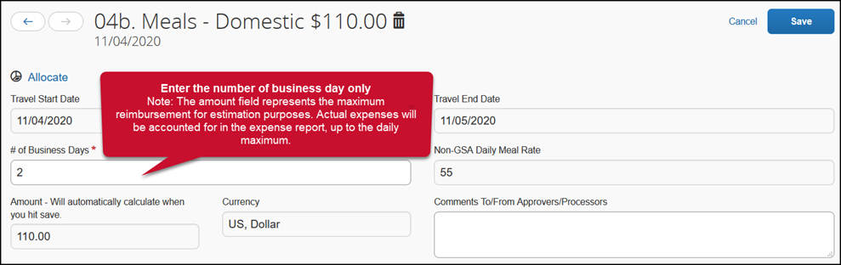
- Allocate
The allocate feature can be used to designate different chartfields for expenses if there is a need for “split” funding of a travel transaction.
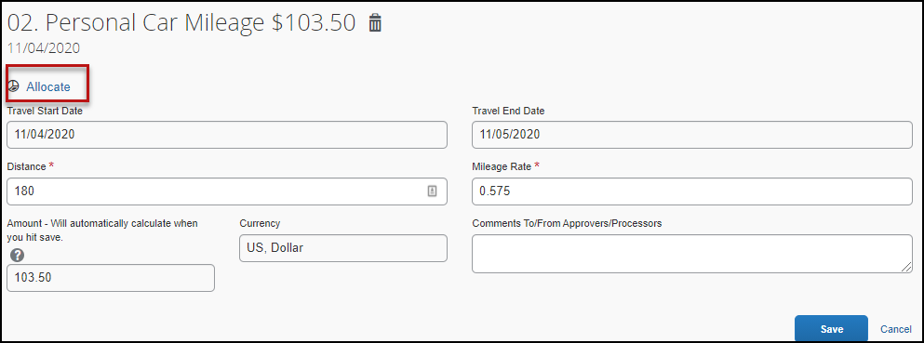
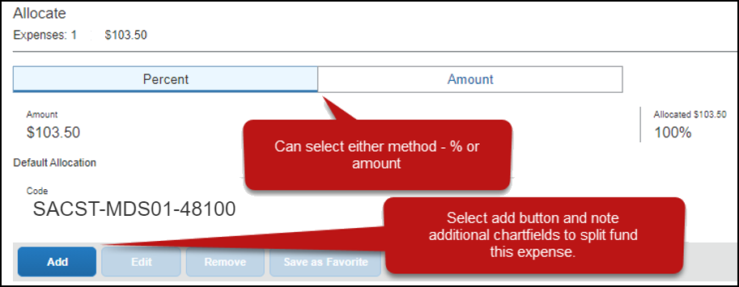

- Request Details
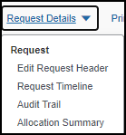 | Edit Request Header - will take you back to the request header where you started and noted the trip demographics. You can revisit an entry in the request header until the request is submitted.  Request Timeline – will show you the approval workflow and what steps have been completed or are outstanding. Once submitted the report will route to the “Budget Approver(s)” (minimum travel signature authority) to approve the funding. This information is based on the chartfield entered on the Request Header tab as well as any additional chartfield allocated at the individual line-item level on the Expenses tab. Once approved at this stage, the request will then route to the employee’s supervisor. If international travel or any other type requires additional review it will move to those responsible for that review – campus approvers, or Chancellor’s Office Risk Management for war risk countries.  Audit Trail – will show you the timestamps of certain actions taken on the travel request.  Allocation Summary – will show you the summary of any chartfield splits that might have been added to the request expenses.
- Print/Share
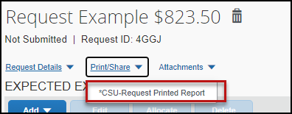 | Hyperlink will give you the option to save request summary as a PDF or share as deemed necessary. Note: It will be retained in the system according to CSU retention guidelines and printing or saving in duplicate is not necessary.

- Attachments
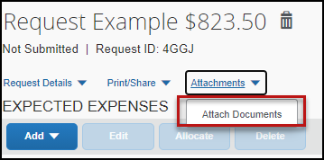 | Hyperlink will give you the option to upload files to attach as support for the trip request. This could be a conference registration showing location/dates of trip, an itinerary for international travel, or any other support document that is helpful to have on hand for approvers.
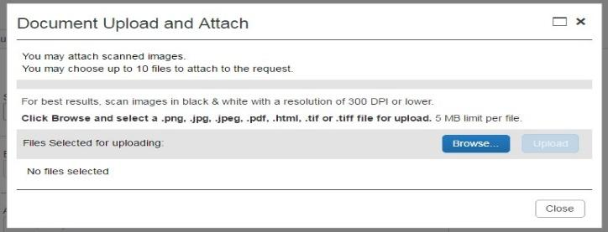
- Alerts
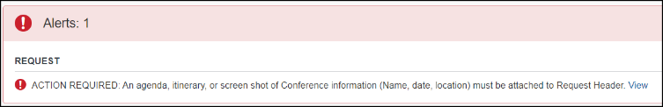  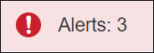  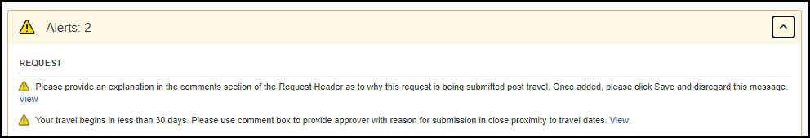  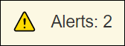 | These will be messages triggered by certain elements of your trip.  A red alert means an action must be taken before a request can be submitted.  A yellow alert panel means there are requests or communication related to your trip components (these will not stop you from submitting your request).  For example, an alert can communicate the need to add comments to explain the trip, to attach files, etc. Alert count may change as requirements are met and alert is no longer necessary.

- Once the travel request is complete, click the Submit Request button.
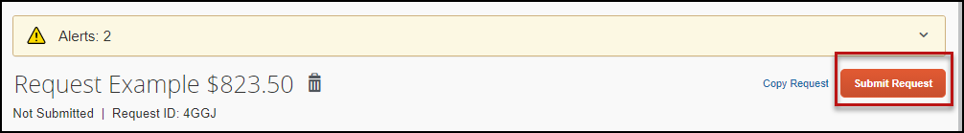

International Travel Request

Travel to international destinations generally follow the same process for creating a travel request as a domestic trip, with a few deviations.

1. Trip type should be designated as 3-International

2. Request must have attachments: Foreign Travel Insurance Request and International Travel Request. The Accounts Payable office will utilize these forms to facilitate working with a traveler for necessary foreign travel insurance and other necessary components for a trip.

3. All expenses should be noted in USD. In the expense report stage currency conversions are more relevant with actual expenses.

Blanket Travel Request for Mileage

Blanket mileage requests can be used for local travel activity, with no overnight stay, for a given fiscal year. These mileage requests are meant to facilitate ongoing mileage reimbursement claims for employees performing supervisory responsibilities for campus student placements, one day travel for meetings off-campus, etc. An example of this would be driving throughout the area to observe and meet with student teachers/interns and mentor teachers.

1. Enter general information about the activity and note the time frame for fiscal year July through June, August through May (academic year). Note the trip purpose as Mileage Only and select Multiple Locations in the Destination City/State field.

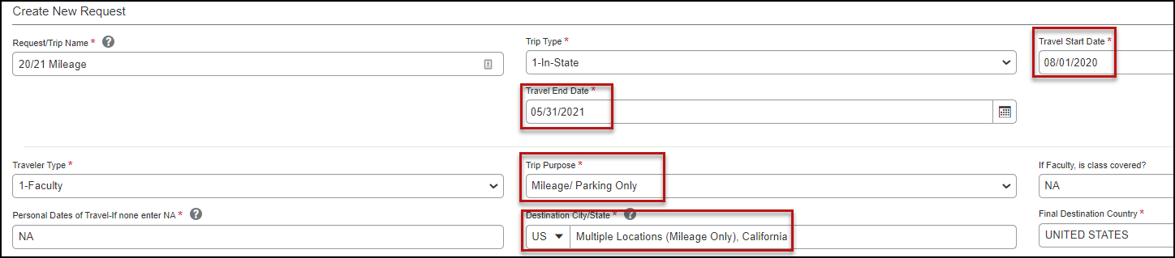

2. Enter estimated mileage/cost for the entire year. Prior year could be used as a reference point and should be adjusted for any known variances for a given year. If necessary, add expense estimates for parking and tolls.

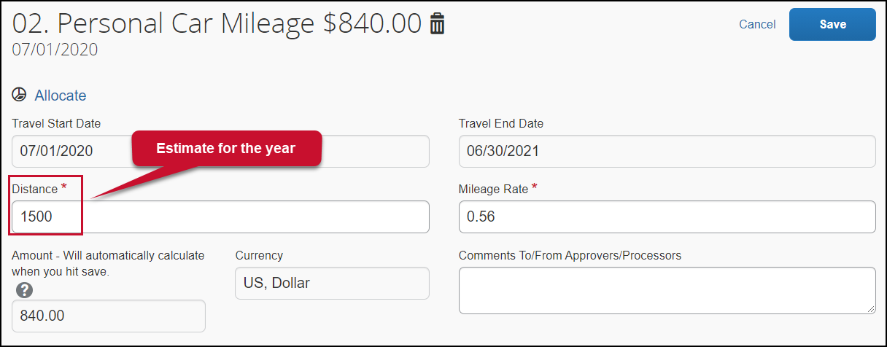
Creating a “Liability Only/Unfunded” Travel Request
Travel with no funding from the campus, e.g. travel that is fully funded by outside sources or by the traveler, needs to be evaluated for connection to University business. If directly connected to University business that supports campus mission, a travel authorization should be completed to communicate time away from campus. This will assist with campus duty of care objectives.

1. Follow steps above to create a travel request. Once trip details have been added to the travel request header, select “Liability/Unfunded” from the expense list.

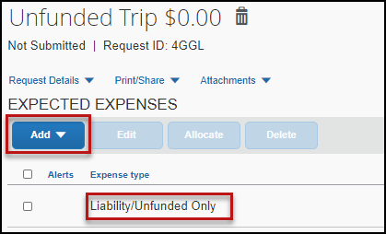

Add a note in the comments field for reference. Once you click Save the Amount will automatically populate with $0.

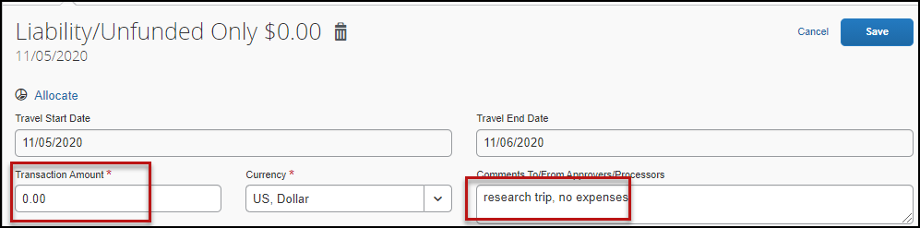

2. Once the trip is approved and you are notified via email, it is best to go back into Concur and follow the steps above for marking the request as “Closed/Inactivate Request.” Otherwise, the request will automatically close on day 61 post trip, but in the meantime, you will be prompted with reminders about submitting expense reports. Marking closed will reflect there are no expected expenses and will eliminate those expense report reminders.

Acting as a Delegate/Travel Arranger

If you have been assigned to work as a delegate, your delegator will define which tasks you can complete, such as booking travel, preparing reports, etc.
To work as a delegate:
- Click Profile.
- Under Acting as other user, enter the delegator’s name or select the appropriate name from the drop down. Note: If you are unable to pull up the name, then you are not set up to delegate for the delegator. You will need to reach out to the individual to have them set you up.
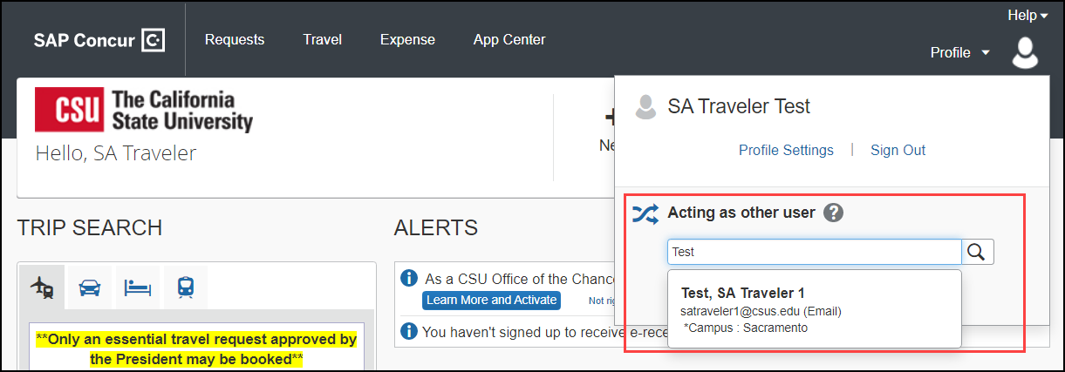
- Click Start Session.
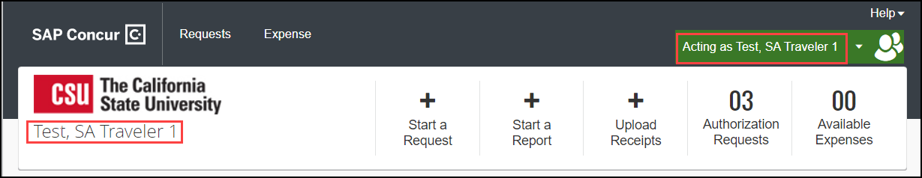
- Notice the Profile menu now displays Acting as and shows the name of the employee you are acting on behalf.
- You are now officially working on behalf of that person. Complete the normal processes for creating the request as noted in the section above, Entering a Travel Request.
- Once the Request is built, the Delegate can use the “Notify Employee” button to let the traveler know the Request is ready to submit. The Traveler must certify and submit their own travel request.
- To select a different user, follow the same steps but click a different name.
- To return to your own tasks, click the down arrow next to Acting as and then click Done acting for others.
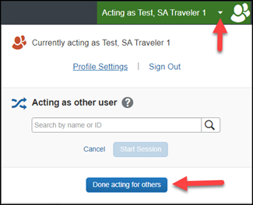

Requesting a Cash Advance
In most cases a travel advance is no longer needed as most travelers can utilize the department ProCard cardholder for registration, can utilize Concur for flight charged to the ghost card, or have a Concur Travel card. However, cash advances will still be available in exceptional cases (specifically for team/group travel) and may be entered on the travel request. To be eligible to request a cash advance through Concur, traveler and department must submit Concur Cash Advance Request form (AP Travel Concur website.) Your Concur settings must be updated to reflect this option by your campus Concur Admin.
Note: If you do not have a Concur Travel Card, and are eligible, make sure you allow yourself enough time to obtain the card before your travel dates. Contact Jenifer Barnett for travel card information.
Once form processed by AP, to Request a Cash Advance:
- Navigate to Request, New Request (or remain in the request currently working on).
- Click Request Details and then choose Add Cash-Advance. Note: A user will not see this option if approval and additional setup noted above has not occurred.
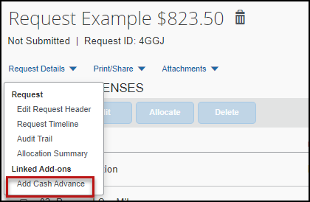

Enter the amount you would like to request for the Cash Advance and then click Add Cash Advance . This will add the cash amount to your travel request and increase the anticipated expense.
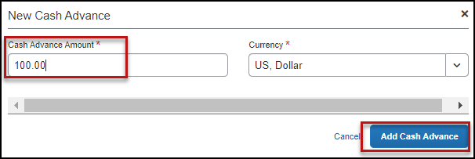

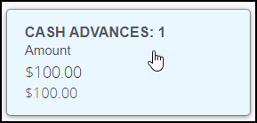
- Click into the Cash Advance box to enter in the following required Comments. Click Save when completed.
  - Request date to receive cash advance.
  - Reason for cash advance.
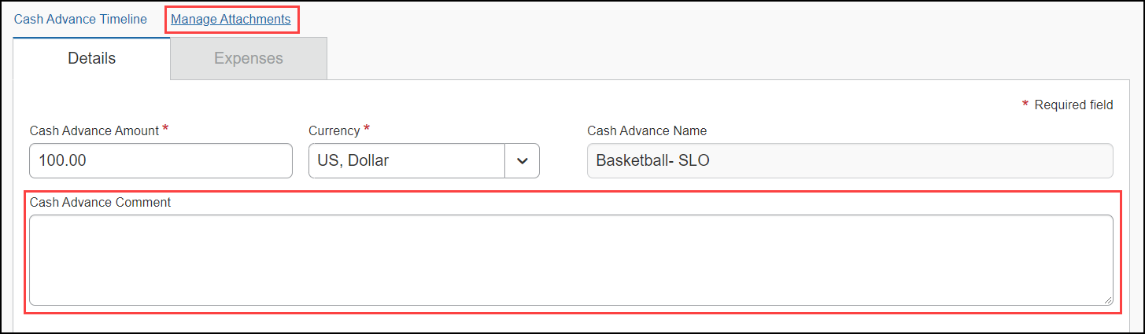

- Complete and Submit Request as normal.

Altering a Request
If there is a need to revisit and alter a request (i.e. because dates, locations, or significant cost changes are necessary), there are a few options:

Recalling a Request
You cannot change, cancel, or delete a Request that has been submitted unless you Recall it first. You can only recall a request that is not in “Approved” status. If the request has been fully approved, you will need to take different steps as noted below in Replacing a Request.
- Click the Request Name from the Manage Requests page.
- Click Recall.
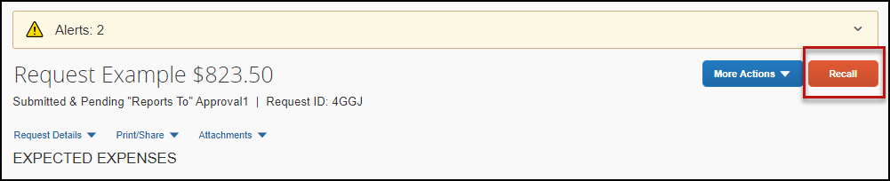
- Click Yes to confirm the Recall. The status of the request is updated to Sent Back to User.
- Make any necessary changes, then select one of the following options Cancel Request (found under More Actions) or Submit Request to resubmit the newly changed request.

Replacing a Request
This step is only needed in the case where a request has been fully approved and details have changed in such a way that the prior approved request is no longer valid.
- Click the box next to the Request Name from the Manage Requests page and select Copy Request.
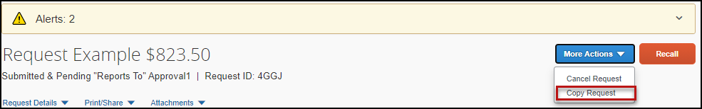
- Enter a different request name (so you can differentiate between old and new) and enter the starting date and check the Expenses box. This helps cut down on duplicative data entry if there are identical expenses between old and new. Click Create New Request button.
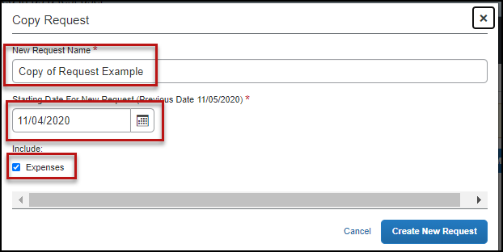
- Make any necessary updates to the new request and submit for approval.
- Make sure to Cancel, then Close/Inactive the old request (see instructions below).
Cancel a Request
If a trip is canceled or elements have changed so significantly that you need to replace a request as noted in the prior section, please cancel the request by going back to the Requests tab and open the request.
1. Open request and select Cancel Request under More Actions. Enter a comment, if applicable, then click OK.
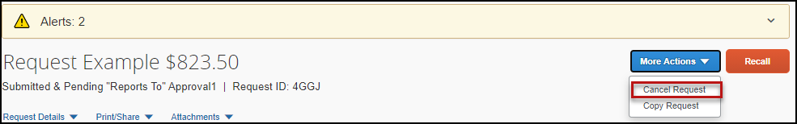
2. Click “Close/Inactivate Request.”
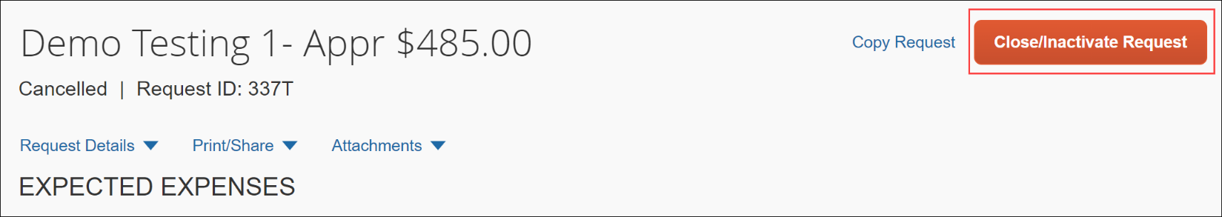
3. If your prior request had booked travel reservations, you would want to go to your Trip Library and make sure they are noted as canceled/withdrawn (if that is your goal). This will ensure the campus/employee does not incur unnecessary expenses for not canceling on time.
Check the “Include withdrawn trips” box and click Search.
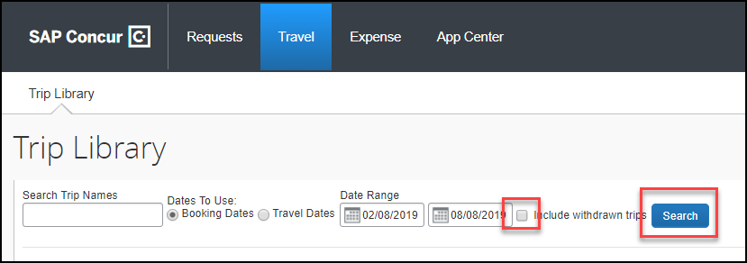
Closing/Inactivating a Request
The system will automatically close open travel requests 61 days after a trip is complete. Reminder, expense reports need to be submitted within 60 days from the end of trip date. If all relative expenses have been submitted a user can manually close/inactivate the request. This is not a required step.
1. Select the Request tab, click on the desired request and under More Actions select Close/Inactivate Request.
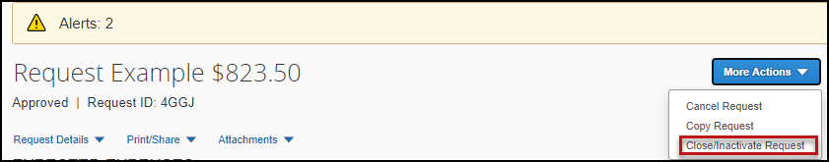
The difference between this status and cancellation is that cancellation signals a true recall of an anticipated trip. Closing/inactivating means the trip is complete. If by chance an expense needs to be submitted after a request is closed, please reach out to the Travel team (apinvoice@sonoma.edu) and we can assist.

